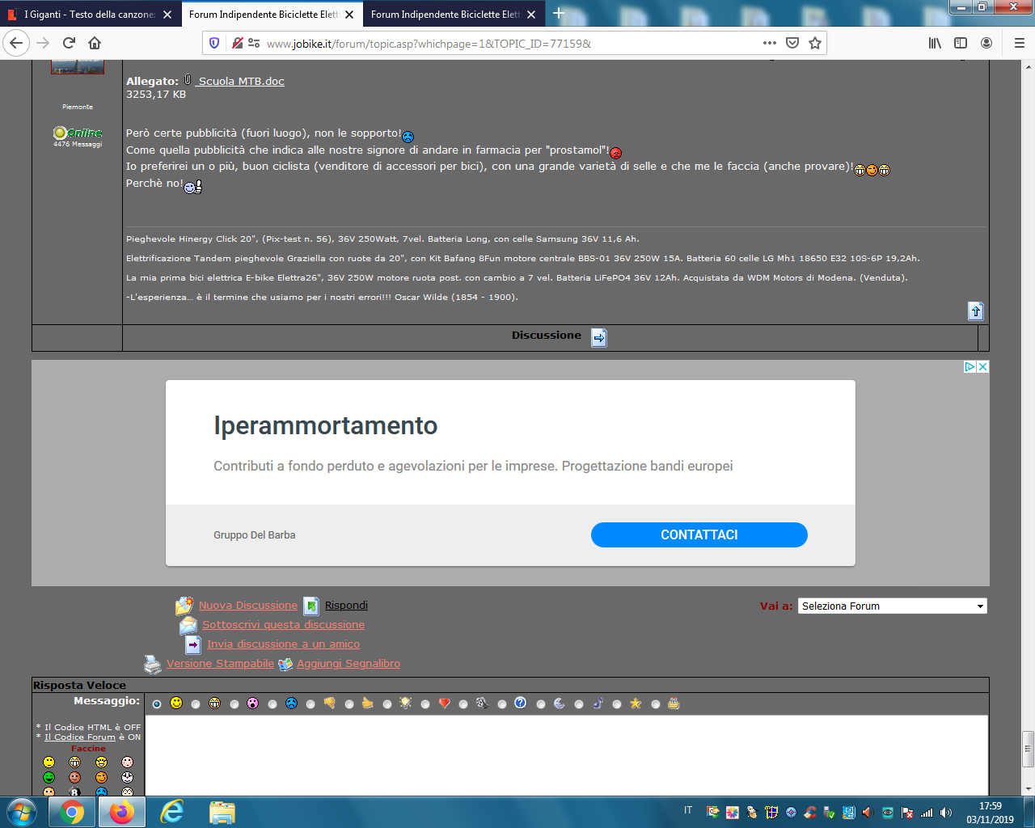

https://www.gruppodelbarba.com/servizi?gclid=EAIaIQobChMIgYWJ78HO5QIVTfJ3Ch31lwAdEAEYASAAEgKTIvD_BwE

